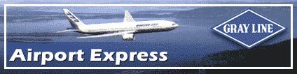

Shuttle Service to and from Seatac Airport to the Grand Hyatt Seattle between the hours of 5am and 11:30pm

At Sea-Tac Airport - Lower Level
North Booth: outside the United Airlines baggage claim area, Door 24.
South Booth: outside the International baggage claim area, Door 8.
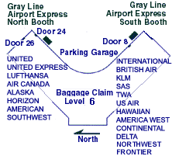
For Reservations
1-800-426-7532
206-626-6088
206-626-5209 fax
4500 W Marginal Way S.W.
Seattle Washington 98106 USA
info@graylineseattle.com

Adults:
One Way $11.00
Roundtrip $18.00

Children (2-12 years):
One Way $8.00
Roundtrip $13.00

Children less than 2 years travel for free.

After you have collected your luggage, follow the signs directing you to ground transportation which is located on the 3rd floor of the parking garage. The 3rd floor is the same level as the baggage claim and lower drive level. To get across the lower drive you must proceed up one floor via escalator or elevator and walk across the sky bridge.
Once in the garage, proceed to our Airport Express booth by following the ground transportation check-in signs. Walk towards the middle and take an escalator or elevator back down one floor to floor three. You will find our booth alongside the SEA-TAC ground transportation information center
The Airport Express departs the Grand Hyatt Seattle at 16 and 46 after each hour, beginning at 5:16am and ending at 11:46pm.



24 Hour Service
Your Share-Ride Door-to-Door Shuttle Express Fare to or from the Airport is $21.00
Your Private, Direct Service Express Car is $50.00 for 1-3 guests.
Your Private, Exclusive Van for 7 or less passengers is $61.00
Your Private, Exclusive Van for 10 or less passengers is $70.00

After you have collected your luggage, follow the signs directing you to ground transportation which is located on the 3rd floor of the parking garage. The 3rd floor is the same level as the baggage claim and lower drive level. To get across the lower drive you must proceed up one floor via escalator or elevator and walk across the sky bridge.
Once in the garage, proceed to our Shuttle Express booth by following the ground transportation check-in signs. Walk towards the middle and take an escalator or elevator back down one floor to floor three. You will find our booth alongside the SEA-TAC ground transportation information center

Contact information:
Reservations: 425.981.7000 * WA Toll Free: 800.487.7433
Headquarters: 425.981.7070 * Fax 425.981.7071
Office Hours: 8:00A - 5:00P, Monday - Friday
Sales: sales@shuttleexpress.com

